STEALTHWORK
Secure Group Policy & File Services Baseline
Test Environment: Lab Implementation Guide & Documentation

Domain: lab.local | VMware Workstation Pro 26H1 | Windows Server 2022
NIST 800-171 / CMMC Awareness | Date: May 16, 2026
By: Omar Haymour
Phase 1 | Phase 2 | Phase 3
Lab Build & Configuration  DC + FS, AD, GPOs, WSUS, Troubleshooting | Security & Documentation  Hardening, GPO Catalog, Permission Model, Scripts | Review & Presentation  20–30 min walkthrough, deliverables

1. Environment Overview
This document covers the full build and configuration of the Stealthwork Secure Group Policy and File Services test environment. The lab was built on VMware Workstation Pro 26H1 using two Windows Server 2022 virtual machines on an isolated host-only network, aligned with NIST 800-171 and CMMC awareness requirements.

1.1: Lab Architecture
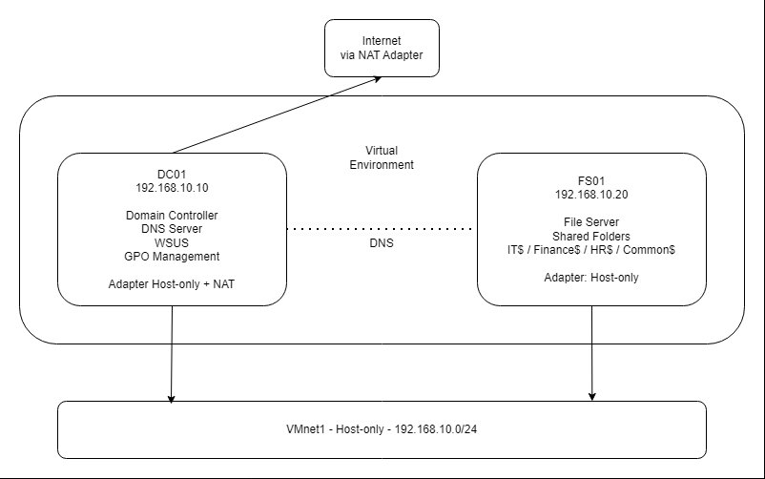
Figure 1: Lab network topology: DC01 and FS01 on VMnet1 host-only network (192.168.10.0/24), DC01 with additional NAT adapter for WSUS internet access

VM | Hostname | IP Address | Roles
VM1 | DC01 | 192.168.10.10 | Domain Controller, DNS, WSUS, GPO Management
VM2 | FS01 | 192.168.10.20 | File Server: IT$, Finance$, HR$, Common$ shares

1.2: VMware Setup
VMware Workstation Pro 26H1 was used as the hypervisor. A custom VMnet1 host-only network was configured with subnet 192.168.10.0/24 and DHCP disabled so that static IPs could be assigned manually.

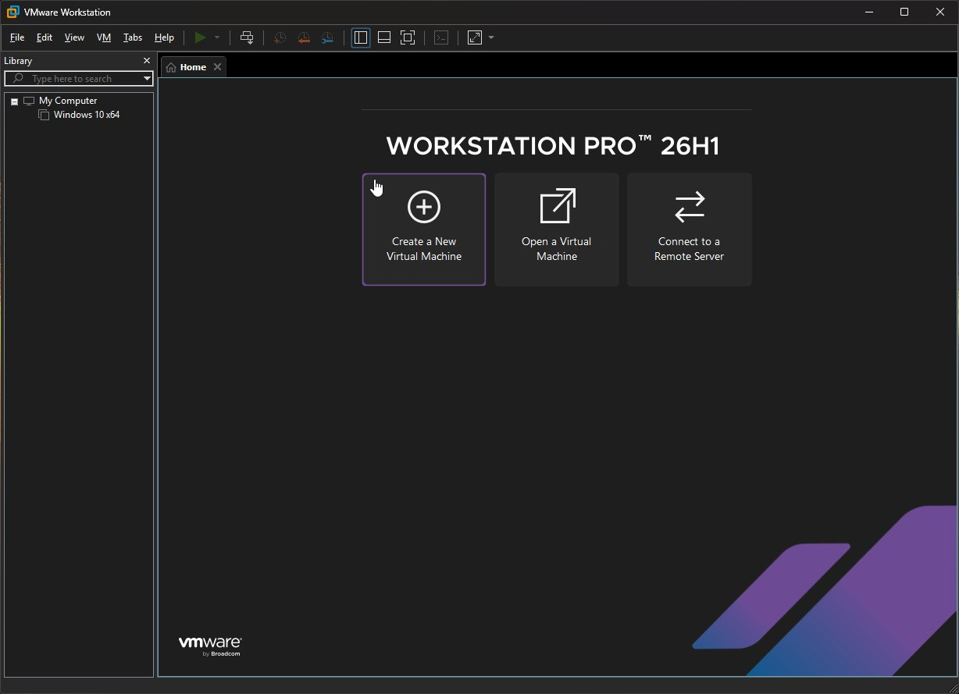
Figure 2: VMware Workstation Pro 26H1 home screen

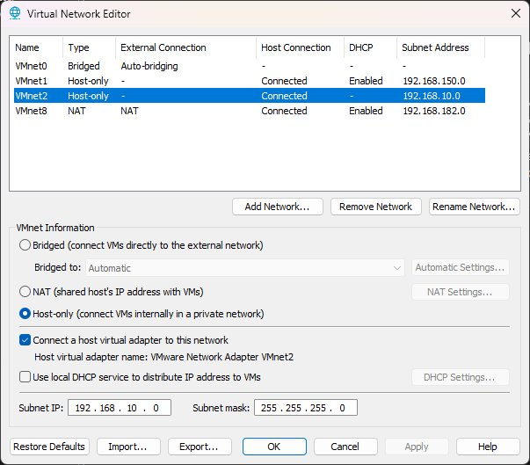
Figure 3: Virtual Network Editor: VMnet1 configured as Host-only, 192.168.10.0/24, DHCP disabled

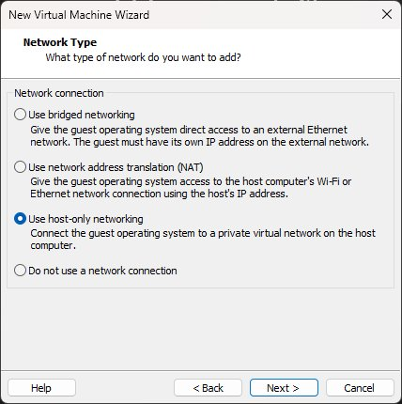
Figure 4: VM creation wizard: Host-only networking selected for both DC01 and FS01

2. Phase 1: Lab Build & Configuration

2.1: Domain Controller Setup (DC01)
Windows Server 2022 Standard Evaluation (Desktop Experience) was installed on DC01. After installation VMware Tools was installed to enable clipboard and performance features. A static IP of 192.168.10.10 was assigned and the server was renamed DC01 before domain promotion.

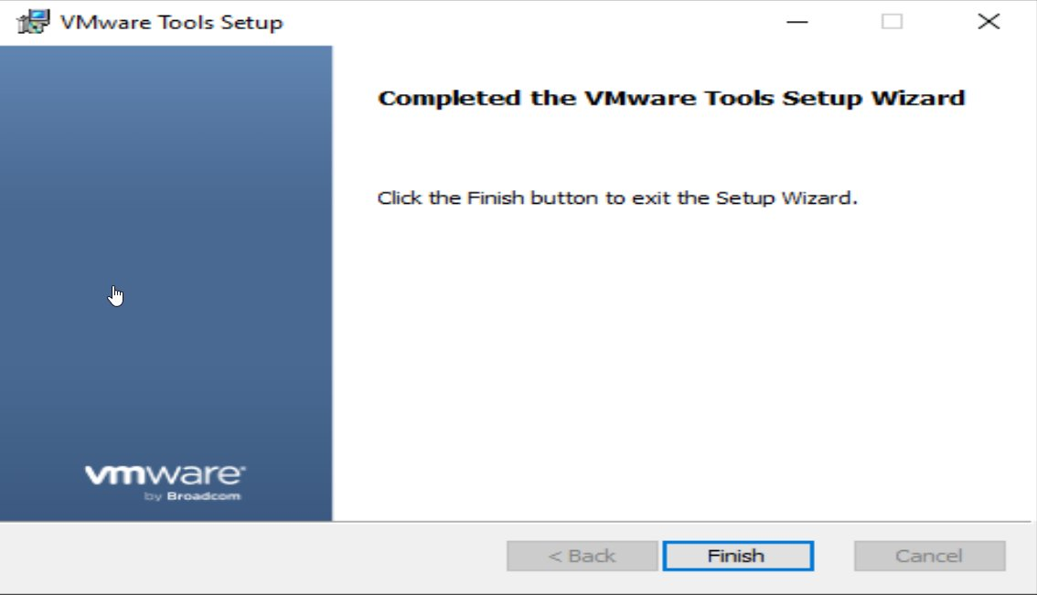
Figure 5: VMware Tools setup completed on DC01

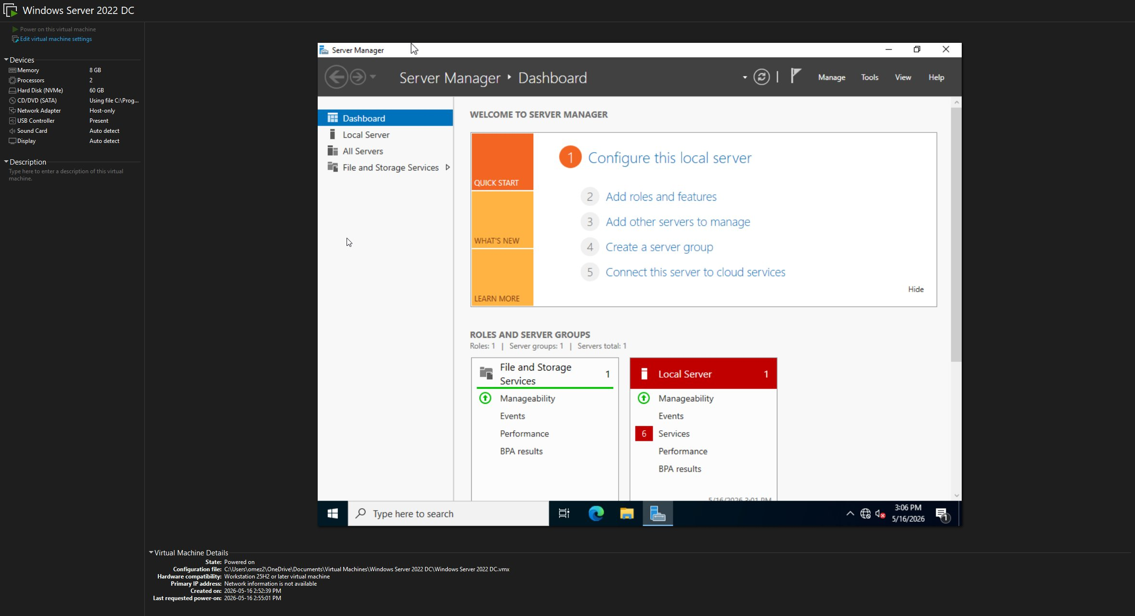
Figure 6: Server Manager dashboard on DC01 after OS installation

2.2: Domain Promotion
DC01 was promoted to a Domain Controller for the new forest lab.local using the Active Directory Domain Services Configuration Wizard. DNS was installed automatically during promotion.

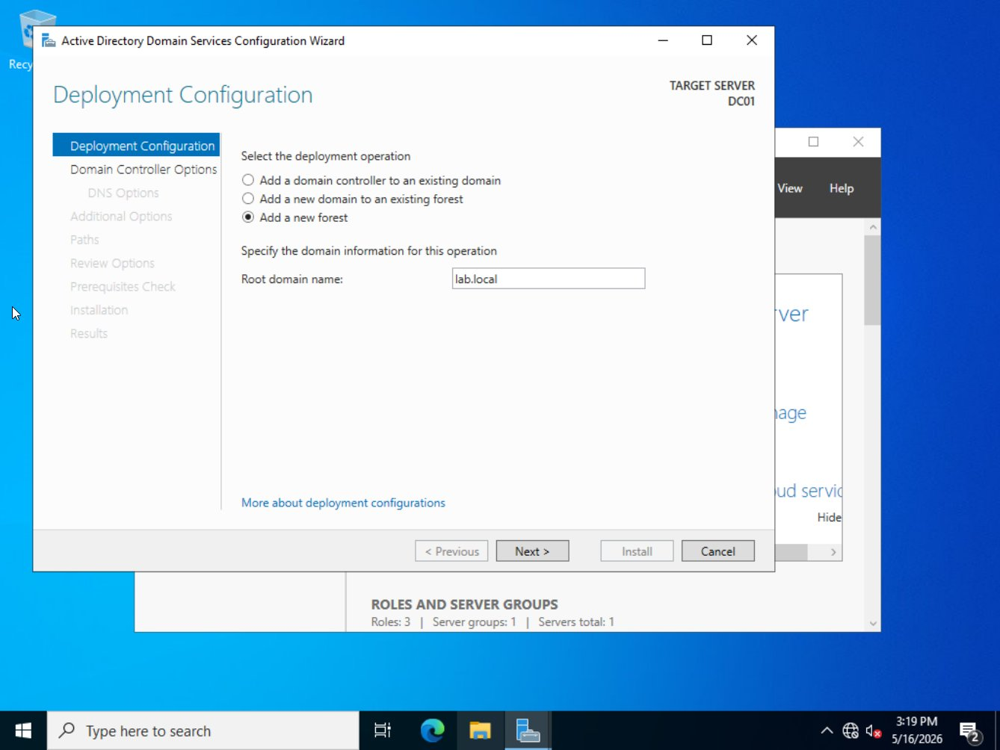
Figure 7: AD DS Configuration Wizard: Add a new forest, root domain name lab.local

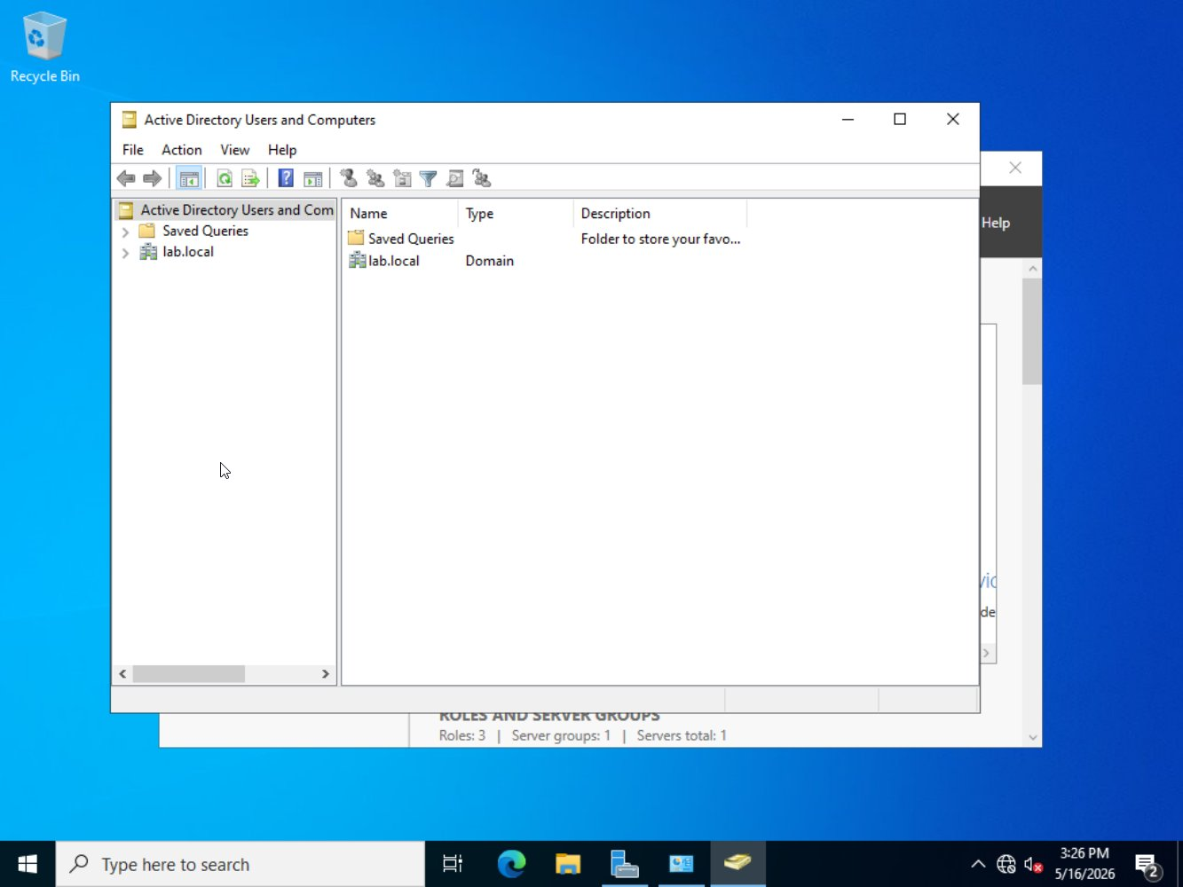
Figure 8: Active Directory Users and Computers confirming lab.local domain is live

2.3: Organizational Unit Structure & Users
A realistic OU hierarchy was created under lab.local to mirror a production environment. Security groups and test user accounts were created and placed in the appropriate OUs.

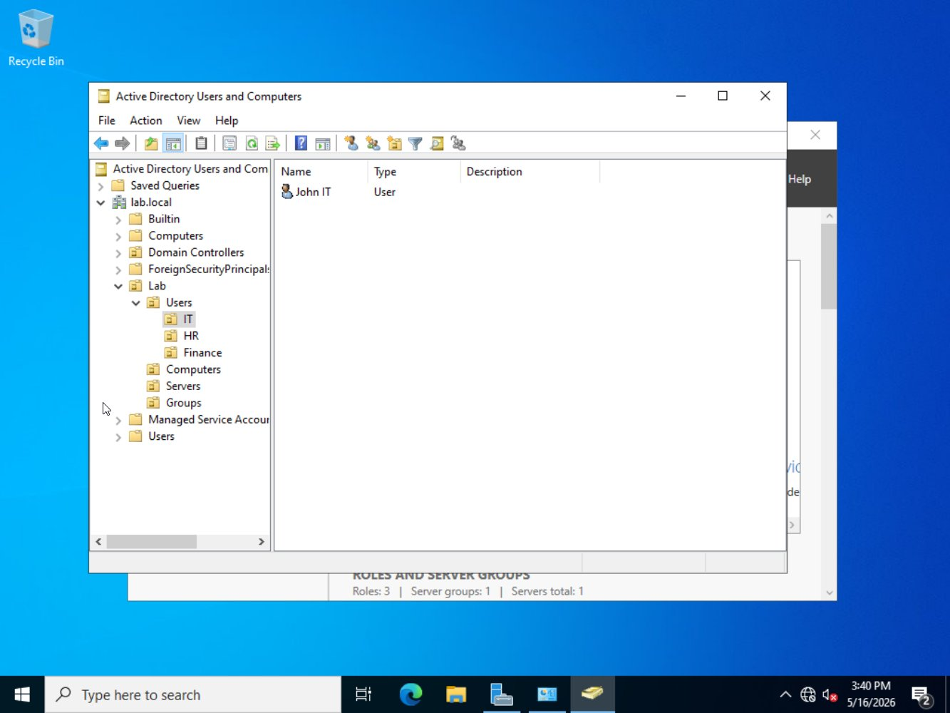
Figure 9: ADUC showing full OU tree: Lab > Users > IT / HR / Finance, plus Computers, Servers, Groups OUs with test user John IT visible in IT OU

2.4: File Server Setup (FS01)
FS01 was installed with Windows Server 2022 Standard Evaluation (Desktop Experience), assigned a static IP of 192.168.10.20, and joined to the lab.local domain. It was then moved to the Servers OU in ADUC.

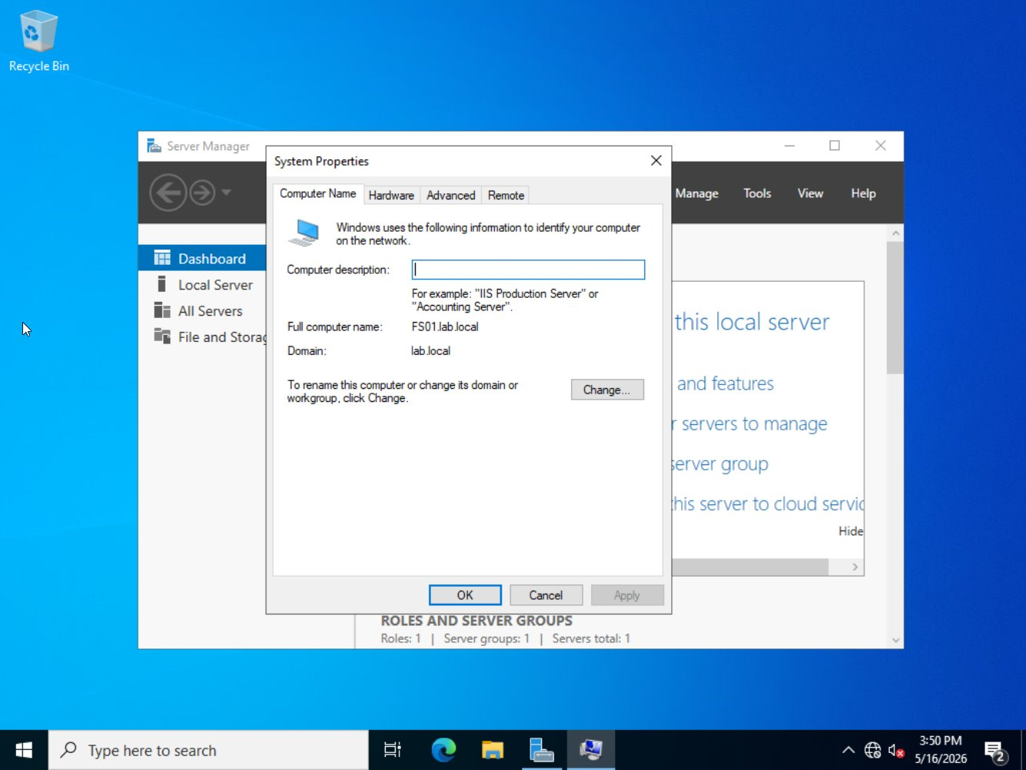
Figure 10: FS01 System Properties showing full computer name FS01.lab.local and domain lab.local

2.5: Secure File Share Permission Model
Four shared folders were created on FS01 under C:\Shares. All NTFS and share permissions are group-based only: no individual user accounts appear in any ACL. The Finance$ share permission structure is shown below as evidence.

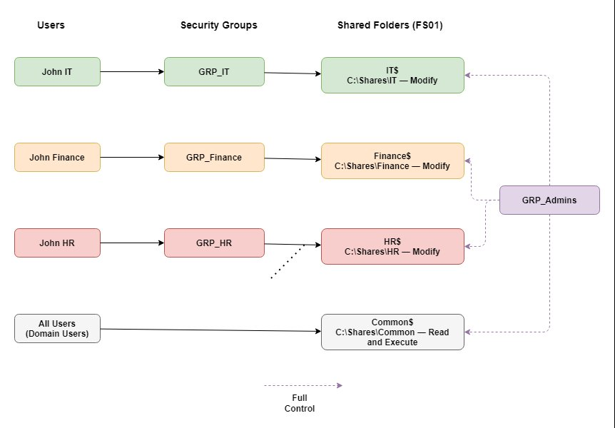
Figure 11: File share permission model: Users map to security groups which are granted group-based NTFS permissions to shared folders on FS01

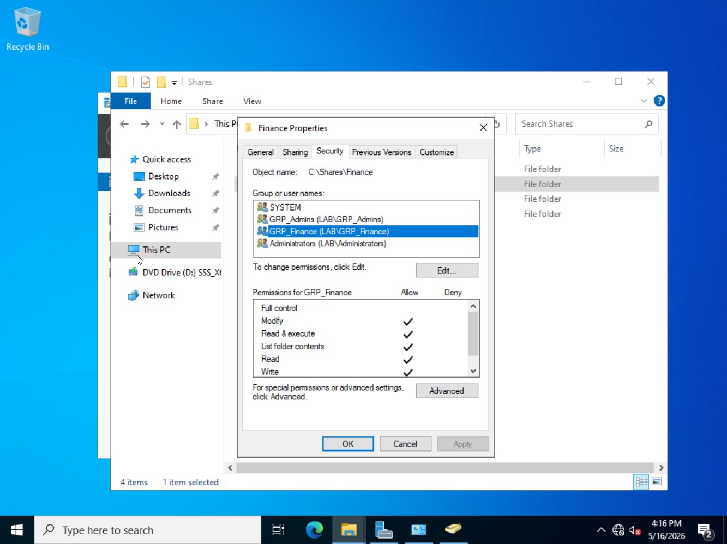
Figure 12: Finance folder NTFS Security tab: GRP_Finance (Modify), GRP_Admins (Full Control), SYSTEM: no individual users

Share | UNC Path | NTFS Permission | Share Permission | Hidden
IT$ | \\FS01\IT$ | GRP_IT: Modify | GRP_Admins: Full | GRP_IT: Change | GRP_Admins: Full | Yes
Finance$ | \\FS01\Finance$ | GRP_Finance: Modify | GRP_Admins: Full | GRP_Finance: Change | GRP_Admins: Full | Yes
HR$ | \\FS01\HR$ | GRP_HR: Modify | GRP_Admins: Full | GRP_HR: Change | GRP_Admins: Full | Yes
Common$ | \\FS01\Common$ | Domain Users: Read & Execute | GRP_Admins: Full | Authenticated Users: Read | GRP_Admins: Full | Yes

3. Group Policy Objects
Seven GPOs were created and linked to appropriate OUs and the domain. All settings were configured via the Group Policy Management Console (GPMC) on DC01.

3.1: Lab-Password-Policy
Linked to: lab.local (domain level). Enforces strong password requirements and account lockout settings across all domain accounts.

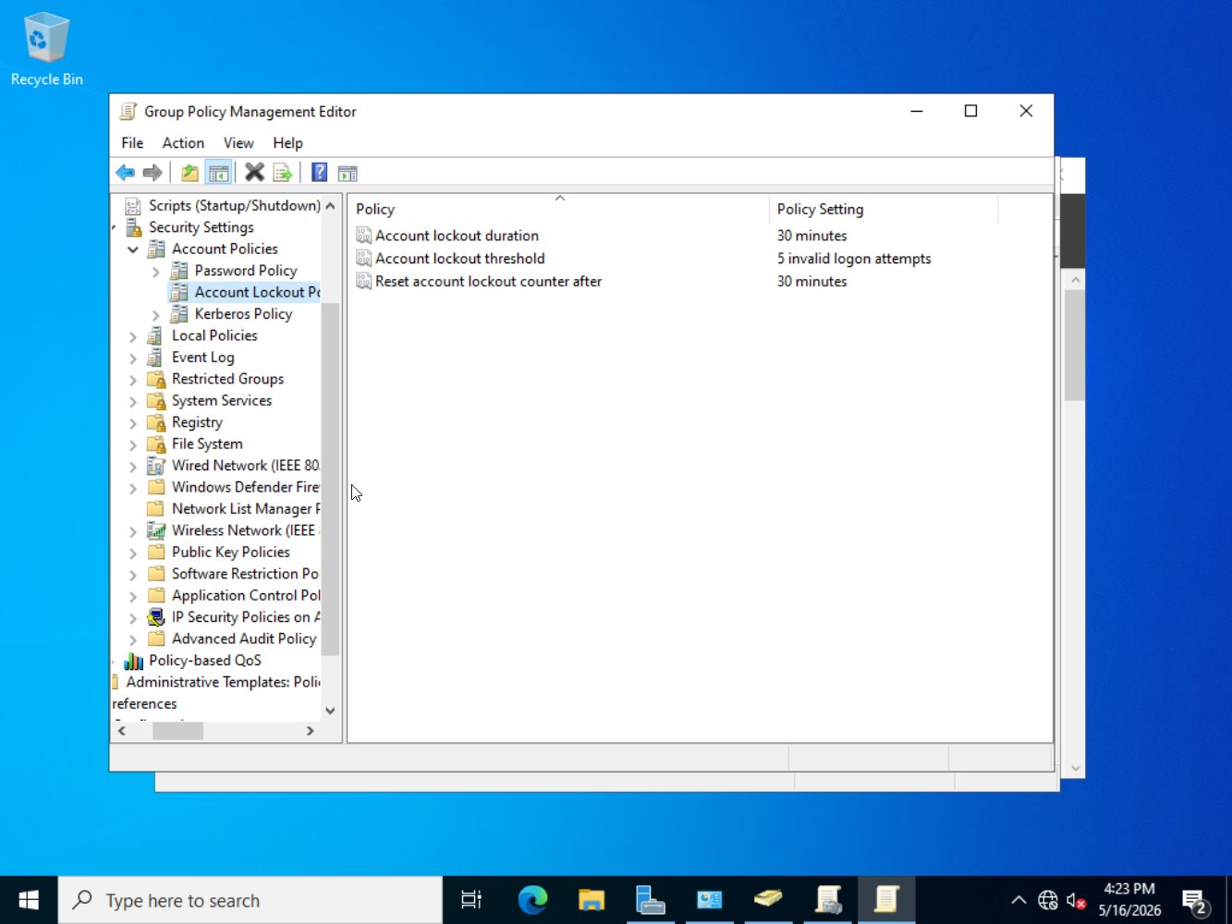
Figure 13: Lab-Password-Policy: Account Lockout Policy showing threshold 5 attempts, duration 30 minutes, reset after 30 minutes

3.2: Lab-Audit-Policy
Linked to: OU=Lab. Enables advanced audit logging for logon events, object access, account management, and policy changes across all lab machines.

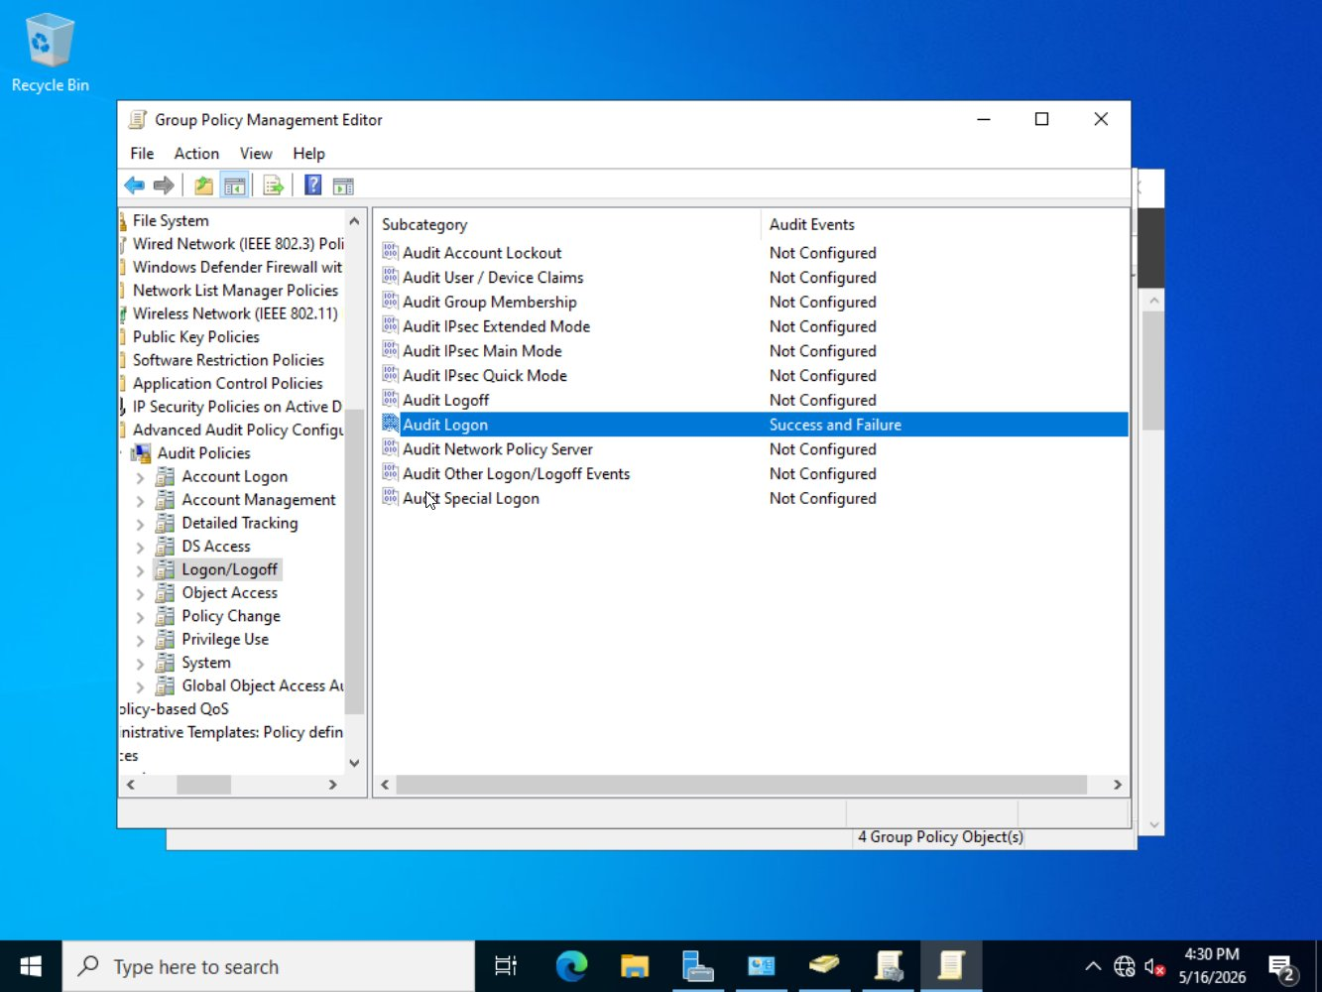
Figure 14: Lab-Audit-Policy: Advanced Audit Policy showing Audit Logon configured for Success and Failure

3.3: Lab-Drive-Maps
Linked to: OU=Users,OU=Lab. Maps department-specific shared drives using Item-Level Targeting so users only receive the drive for their security group.

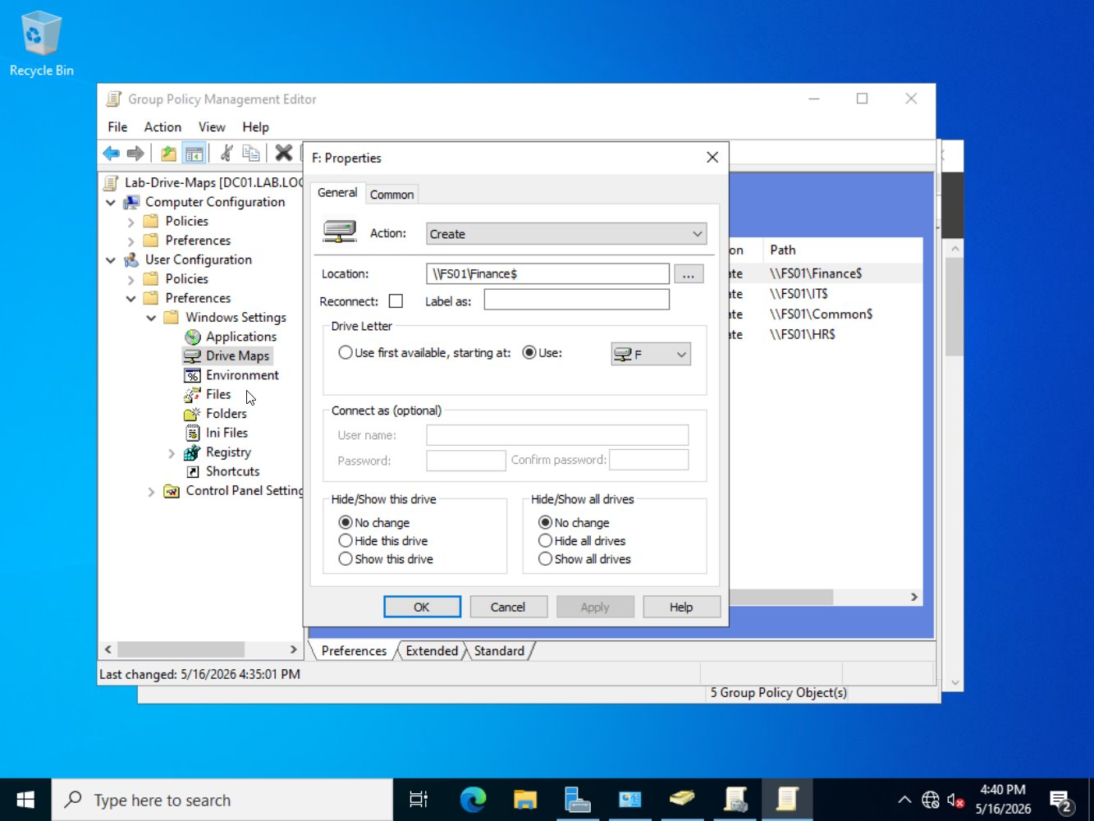
Figure 15: Lab-Drive-Maps GPO: Finance$ share mapped to F: drive with Action set to Create

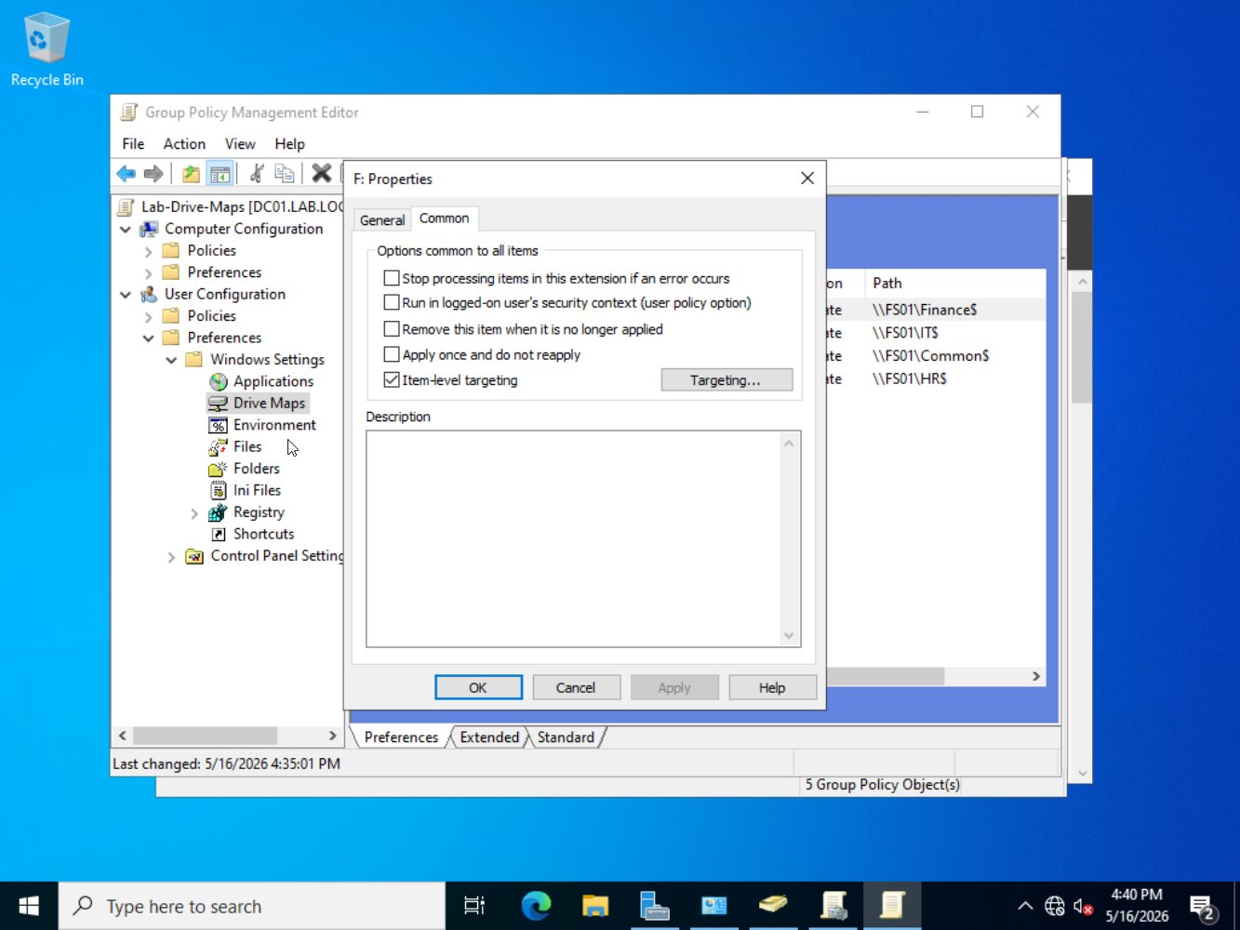
Figure 16: Drive Maps Common tab: Item-level targeting enabled for GRP_Finance group membership

3.4: Lab-RDP-Hardening
Linked to: OU=Servers,OU=Lab. Enforces Network Level Authentication, SSL security layer for RDP sessions, and restricts RDP access to the lab subnet only via a firewall rule.

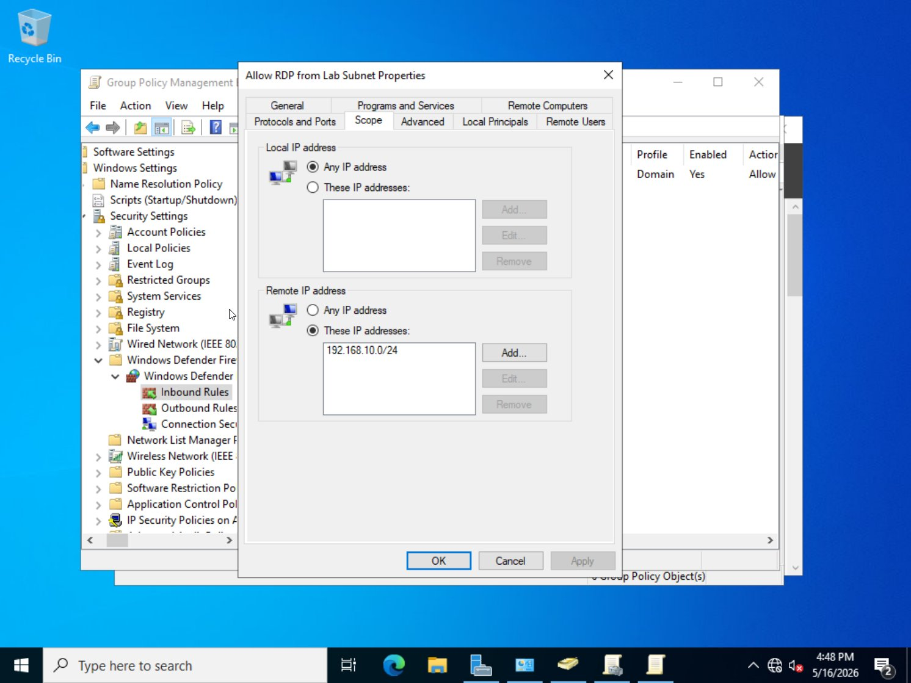
Figure 17: Lab-RDP-Hardening: Firewall rule scope restricting RDP (TCP 3389) to remote IPs 192.168.10.0/24 only

3.5: Lab-Software-Restriction
Linked to: OU=Users,OU=Lab. Default security level set to Disallowed with path rule exceptions for %PROGRAMFILES%, %WINDIR%, and an explicit Disallow rule for C:\Shares to prevent execution from shared folders.

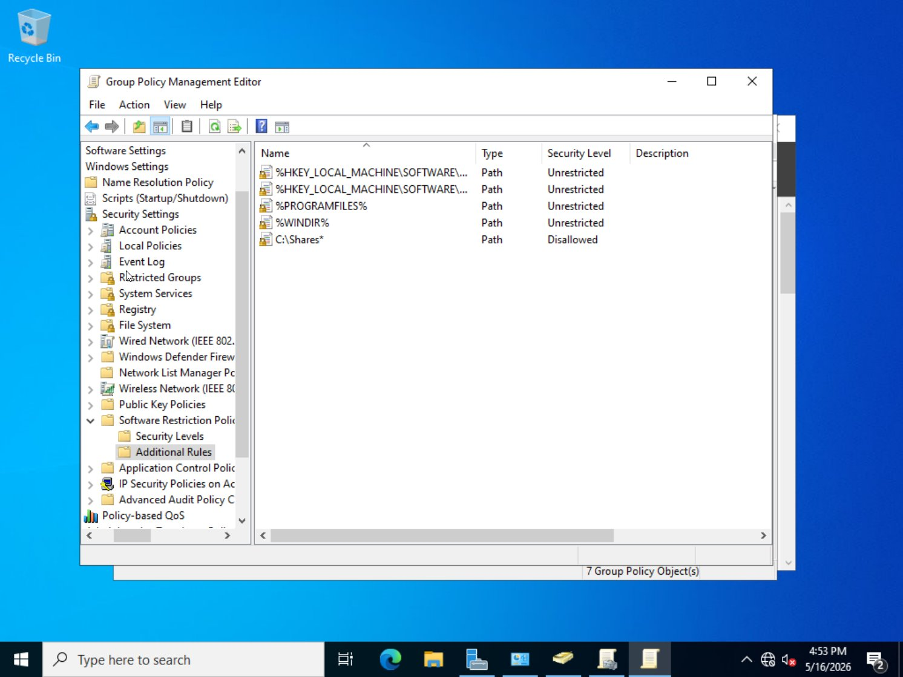
Figure 18: Lab-Software-Restriction: Additional Rules showing %PROGRAMFILES% and %WINDIR% as Unrestricted, C:\Shares* as Disallowed

3.6: Lab-WSUS-Policy
Linked to: lab.local (domain level). Redirects all Windows Update clients to the internal WSUS server running on DC01 at port 8530 for centralized patch management.

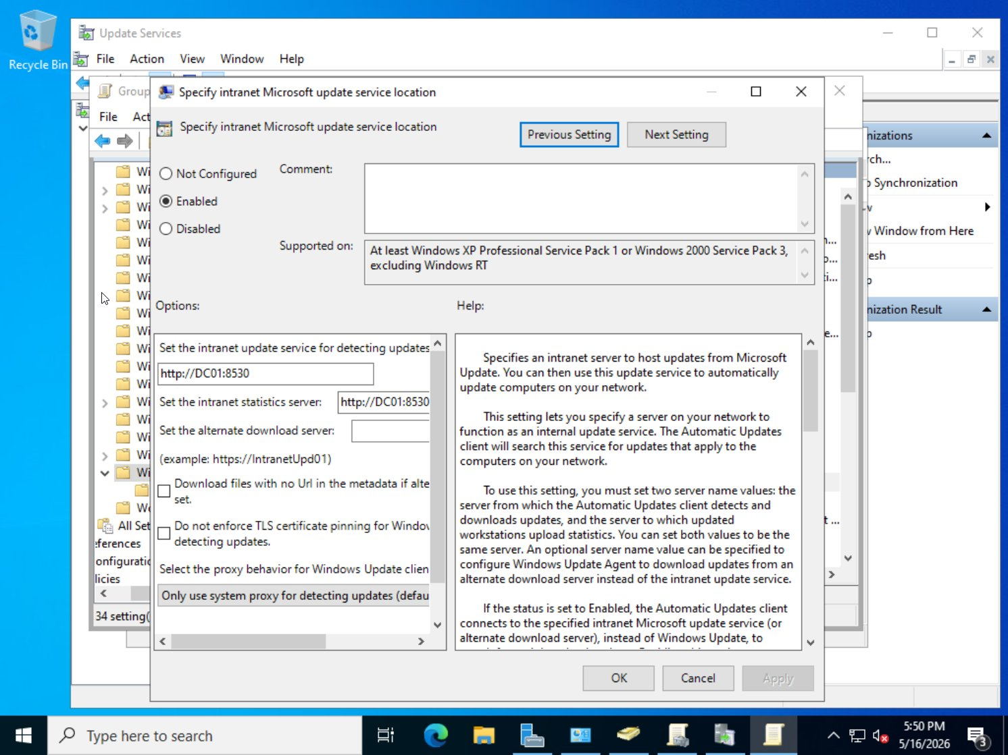
Figure 19: Lab-WSUS-Policy: Intranet update service location set to http://DC01:8530 for both update and statistics servers

3.7: Lab-Hardening
Linked to: OU=Lab. Applies additional security hardening controls including Windows Firewall configuration, SMB signing, logon banner, guest account disable, and Defender settings.

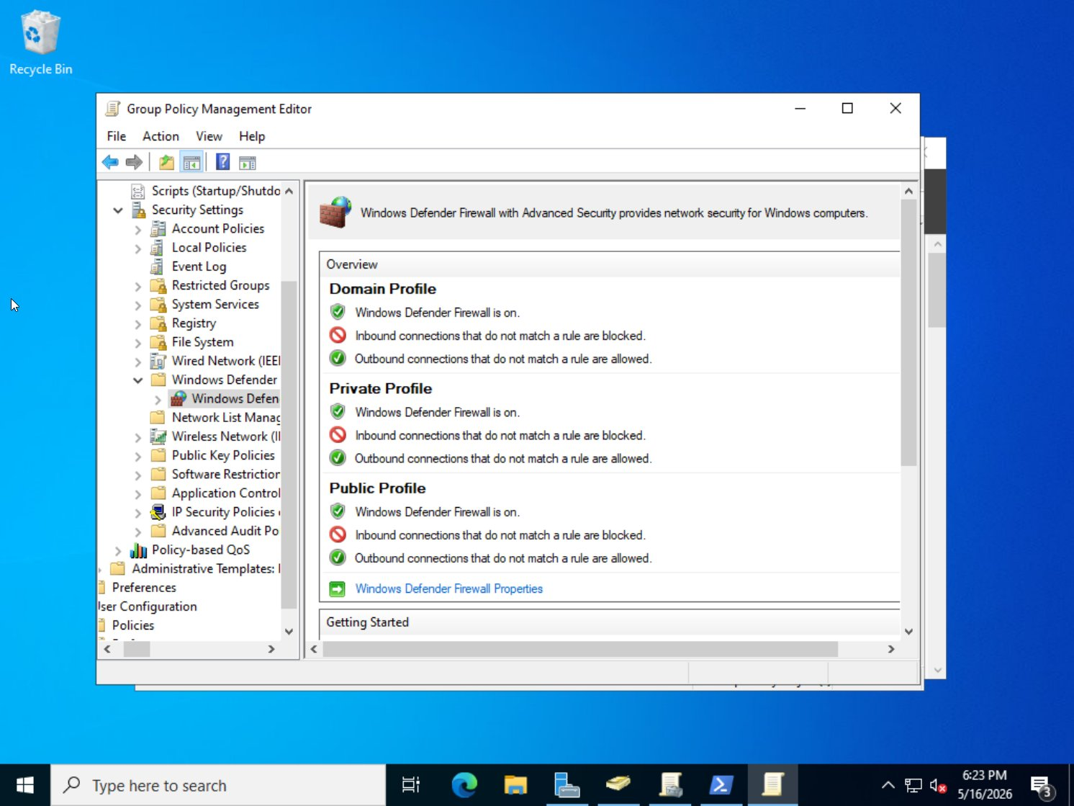
Figure 20: Lab-Hardening: Windows Defender Firewall with Advanced Security: all three profiles (Domain, Private, Public) have firewall on and inbound connections blocked

3.8: GPO Catalog
Complete reference table of all implemented policies:

GPO | Policy Path | Setting Applied | NIST 800-171
Lab-Password-Policy | Account Policies > Password Policy > Min Length | 14 characters | 3.5.7: Identifier Mgmt
Lab-Password-Policy | Account Policies > Password Policy > Complexity | Enabled | 3.5.7
Lab-Password-Policy | Account Lockout > Threshold | 5 invalid attempts | 3.5.6: Authenticator Mgmt
Lab-Password-Policy | Account Lockout > Duration | 30 minutes | 3.5.6
Lab-Audit-Policy | Adv. Audit > Logon/Logoff > Audit Logon | Success and Failure | 3.3.1: Audit & Accountability
Lab-Audit-Policy | Adv. Audit > Object Access > File System | Success and Failure | 3.3.1
Lab-Audit-Policy | Adv. Audit > Account Mgmt > User Accounts | Success and Failure | 3.3.2
Lab-Drive-Maps | User Config > Preferences > Drive Maps | F: Finance$, I: IT$, H: HR$, Z: Common$: Item-level targeting | 3.1.1: Access Control
Lab-RDP-Hardening | Remote Desktop > Require NLA | Enabled | 3.1.12: Remote Access
Lab-RDP-Hardening | Remote Desktop > Security Layer | SSL (TLS) | 3.13.8: Data in Transit
Lab-RDP-Hardening | Firewall > Inbound RDP Source IP | 192.168.10.0/24 only | 3.13.6: Network Access
Lab-Software-Restriction | Software Restriction > Default Level | Disallowed | 3.4.8: App Exec Policy
Lab-WSUS-Policy | Windows Update > Intranet Update Service | http://DC01:8530 | 3.14.1: Flaw Remediation
Lab-Hardening | Security Options > Guest Account Status | Disabled | 3.1.1
Lab-Hardening | Security Options > Logon Banner | Authorized Use Only | 3.1.9: System Use Notification
Lab-Hardening | Firewall > All Profiles Inbound | Block | 3.13.6

4. WSUS: Patch Management
Windows Server Update Services was installed on DC01 and configured to synchronize with Microsoft Update daily. During initial setup a second network adapter (NAT) was temporarily added to DC01 to allow internet access for the initial WSUS catalog sync. Products selected: Windows Server version 21H2 and later. Classifications: Critical Updates, Security Updates, Definition Updates.

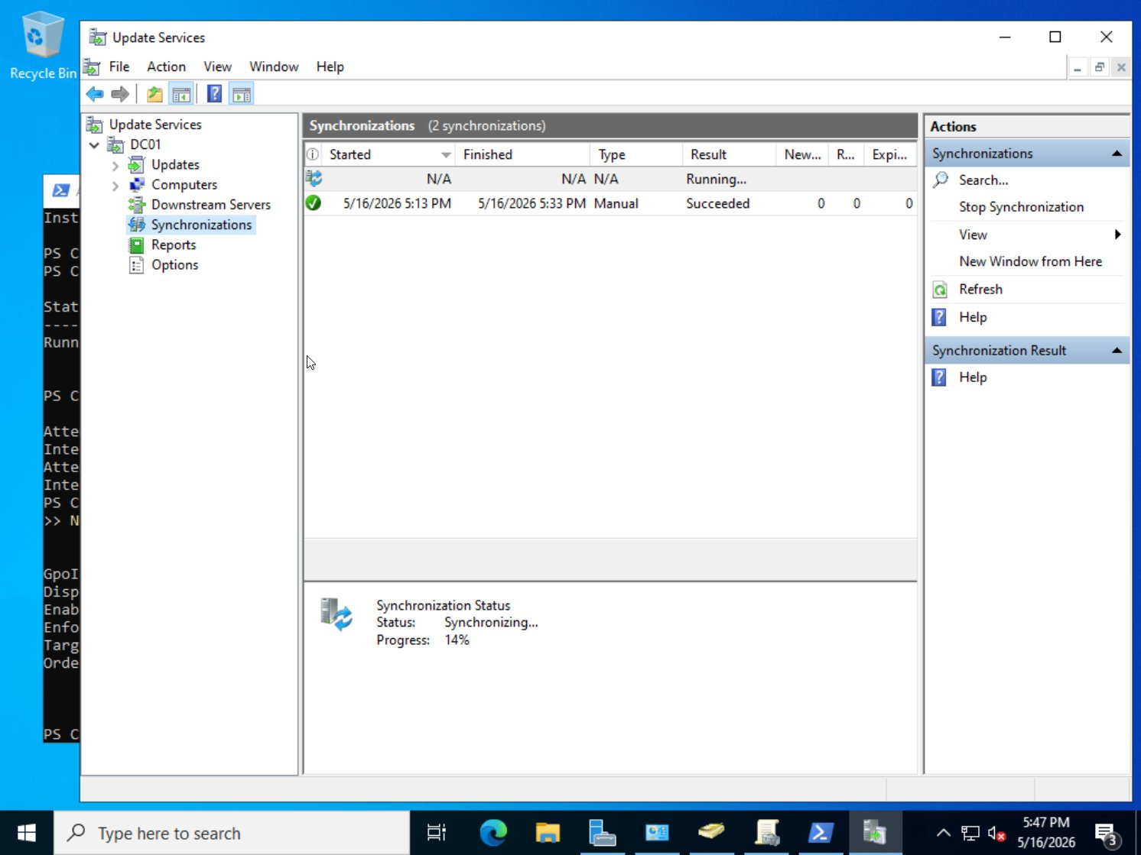
Figure 21: WSUS Synchronizations console: one successful manual sync completed (5:13 PM–5:33 PM), second sync running at 14%

5. Security Hardening
The following hardening controls were applied beyond the base GPO configuration, verified via PowerShell commands and screenshot evidence.

5.1: SMBv1 Disabled / SMB Signing Enabled
SMBv1 was disabled and SMB signing was enforced on both DC01 and FS01 to prevent man-in-the-middle and relay attacks, aligned with NIST 800-171 control 3.13.8.

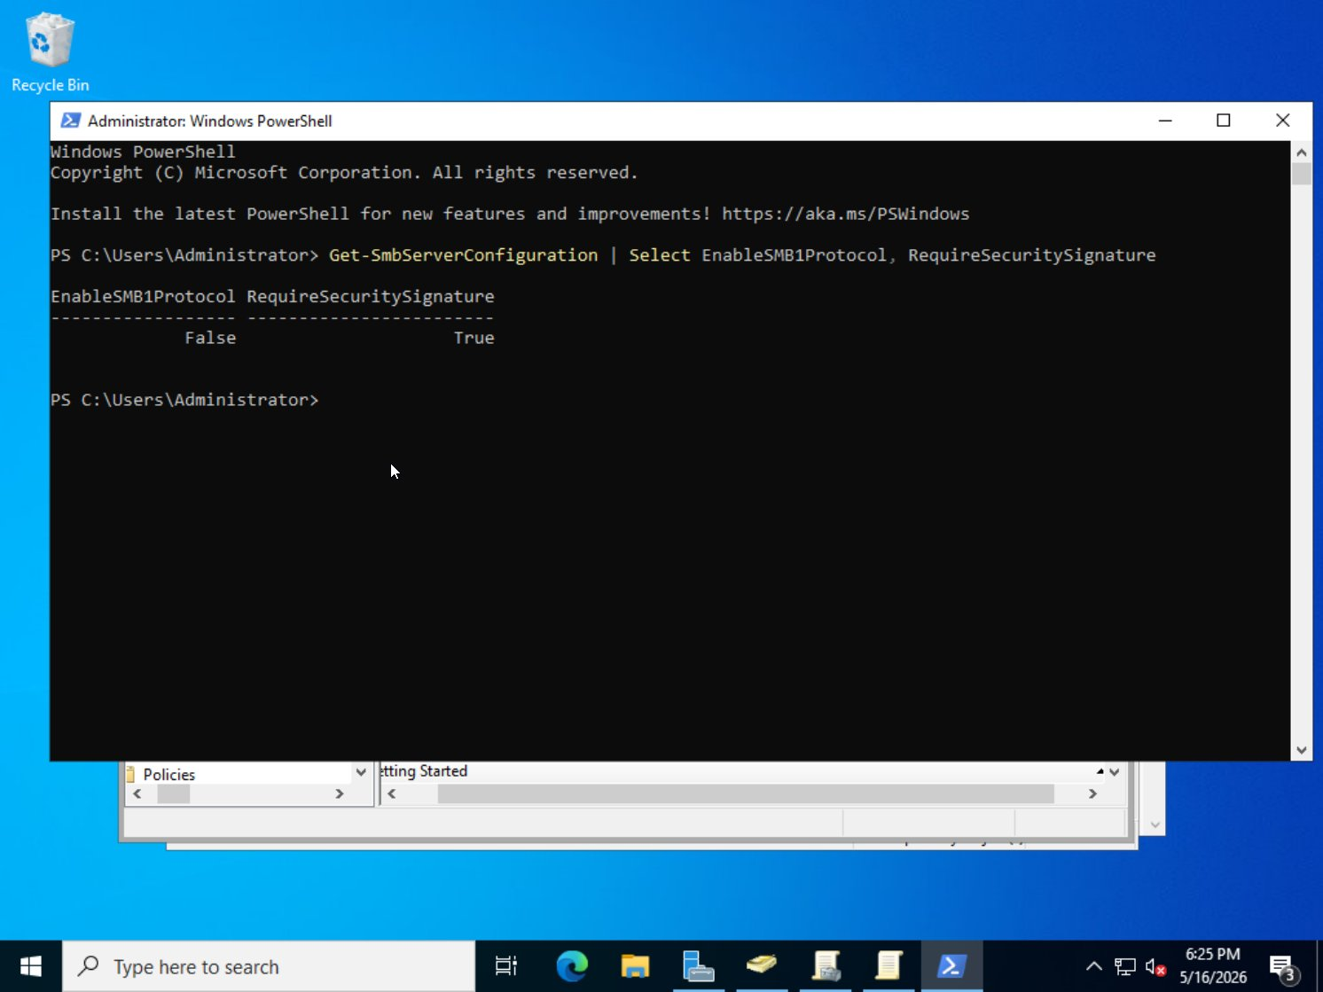
Figure 22: PowerShell: Get-SmbServerConfiguration output confirming EnableSMB1Protocol = False and RequireSecuritySignature = True

5.2: Group Policy Successfully Applied (Event Viewer Evidence)
Event Viewer was used to confirm security policies were applied successfully across the domain. Event ID 1704 from source SceCli confirms Group Policy security settings applied without error.

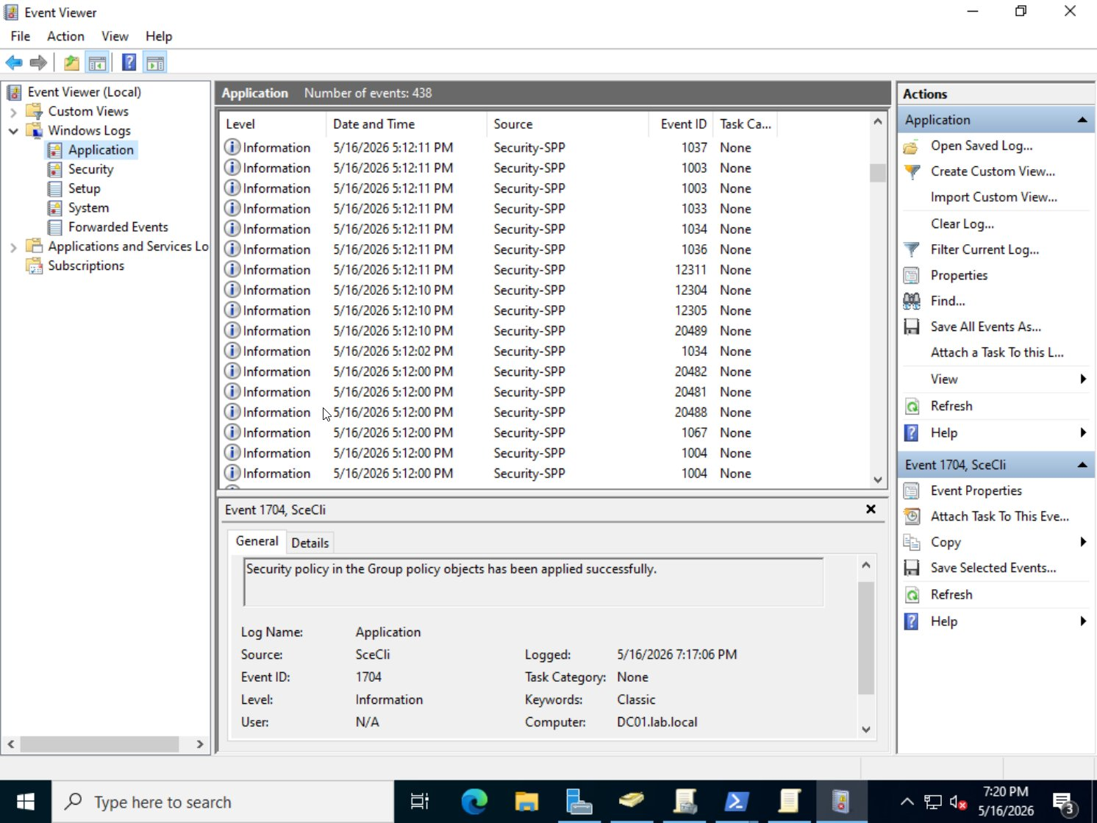
Figure 23: Event Viewer Application log: Event ID 1704, SceCli: Security policy in Group Policy objects has been applied successfully on DC01.lab.local

6. Troubleshooting Documentation
Three common issues were introduced intentionally and resolved during the lab build. Each was documented using real diagnostic tools: gpresult, Event Viewer, and rsop.msc. All issues were real challenges encountered during the build process.

Issue #1: GPO Not Applying (Tool: gpresult)
Field | Details
Introduced | Lab-Password-Policy GPO link was deleted from lab.local in GPMC, disconnecting the password policy from the domain
Symptom | gpresult /r showed Lab-Password-Policy missing from Applied Group Policy Objects. Password enforcement dropped to default.
Tool Used | gpresult /r: run on DC01 to list currently applied GPOs before and after fix
Resolution | Re-linked Lab-Password-Policy to lab.local in GPMC. Ran gpupdate /force. gpresult /r confirmed policy returned to Applied GPO list.

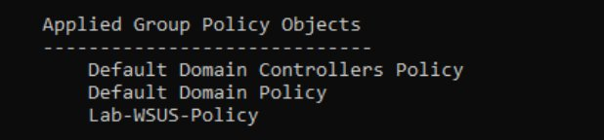
Figure 24: BEFORE FIX: gpresult Applied Group Policy Objects: Lab-Password-Policy absent, only Lab-WSUS-Policy visible alongside default policies

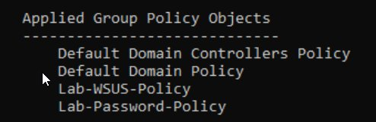
Figure 25: AFTER FIX: gpresult Applied Group Policy Objects: Lab-Password-Policy restored and confirmed applied alongside Lab-WSUS-Policy

Issue #2: Wrong WSUS URL Applied (Tool: Event Viewer)
Field | Details
Introduced | Lab-WSUS-Policy GPO was edited to set the intranet update service URL to http://Hello:8530: an invalid/nonexistent server address
Symptom | Registry confirmed wrong URL via PowerShell: WUServer = http://Hello:8530. Event Viewer Application log showed WSUS Event ID 12072 errors: content directory inaccessible, unable to connect to remote server.
Tool Used | Event Viewer > Windows Logs > Application: filtered for Windows Server Update Services errors. PowerShell registry check: Get-ItemProperty HKLM:\SOFTWARE\Policies\Microsoft\Windows\WindowsUpdate
Resolution | Corrected URL in Lab-WSUS-Policy GPO back to http://DC01:8530. Ran gpupdate /force. Registry check confirmed WUServer = http://DC01:8530.

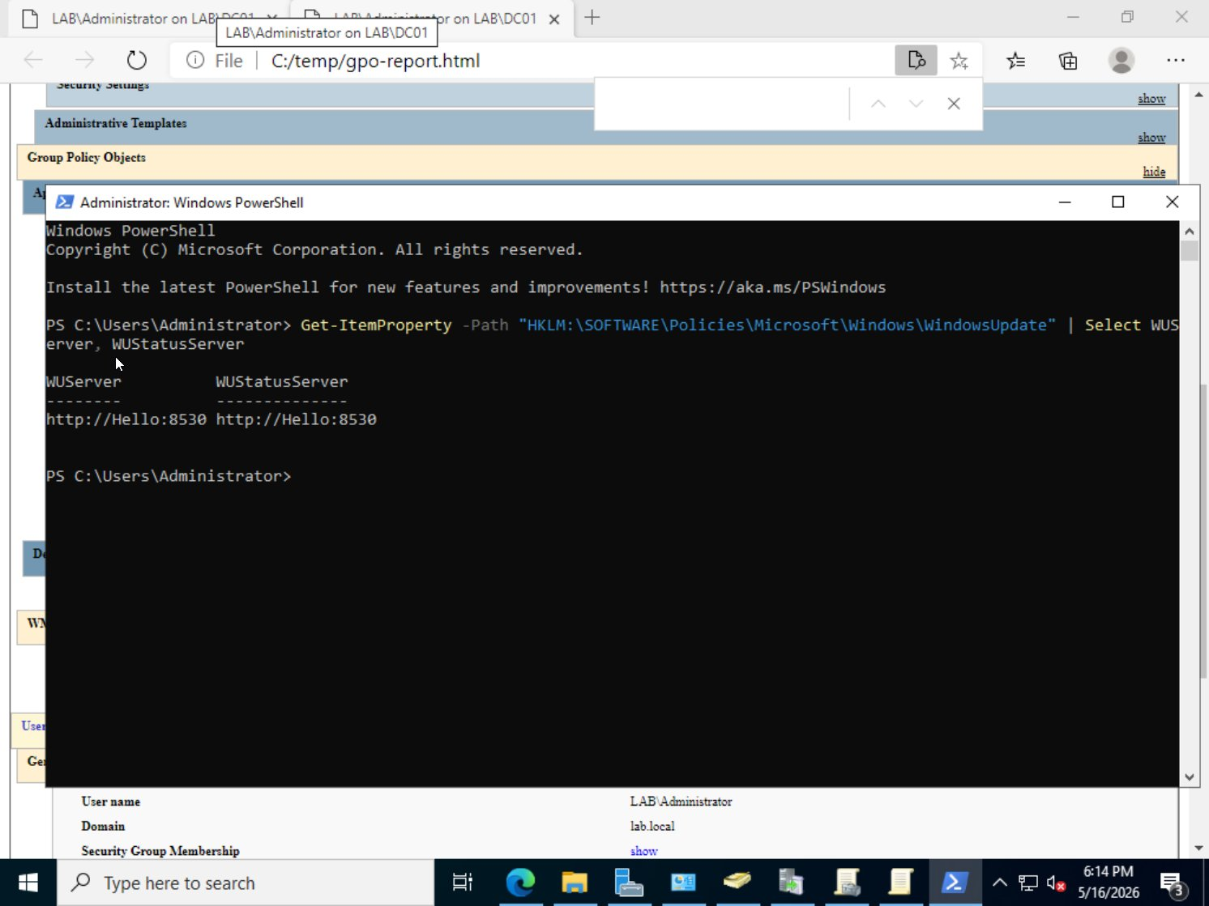
Figure 26: BEFORE FIX: PowerShell registry check showing WUServer = http://Hello:8530: wrong WSUS server URL applied via GPO

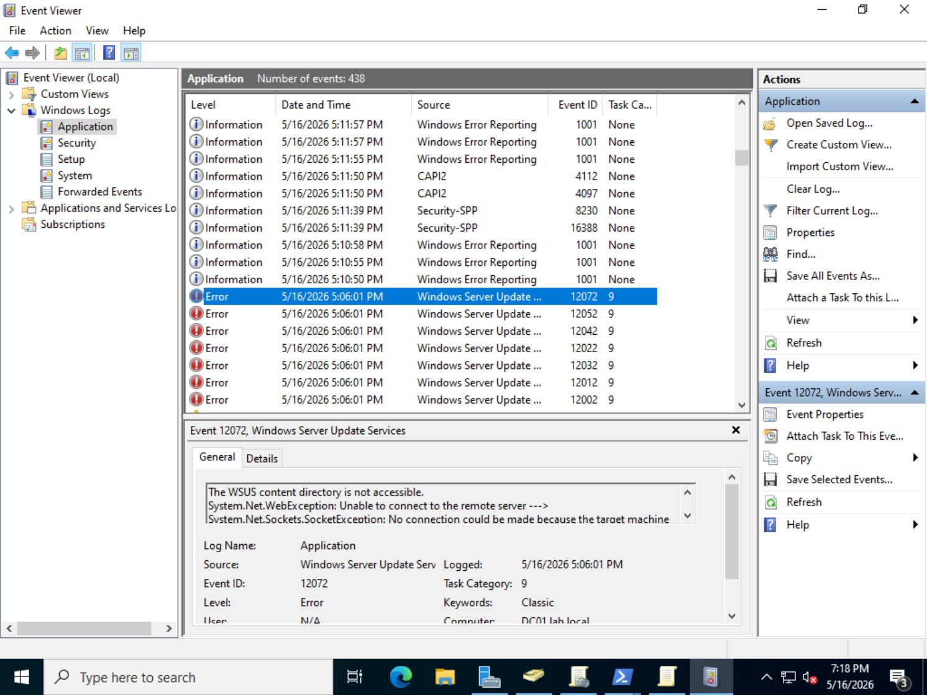
Figure 27: Event Viewer Application log: WSUS Event ID 12072 errors: WSUS content directory inaccessible due to wrong server URL

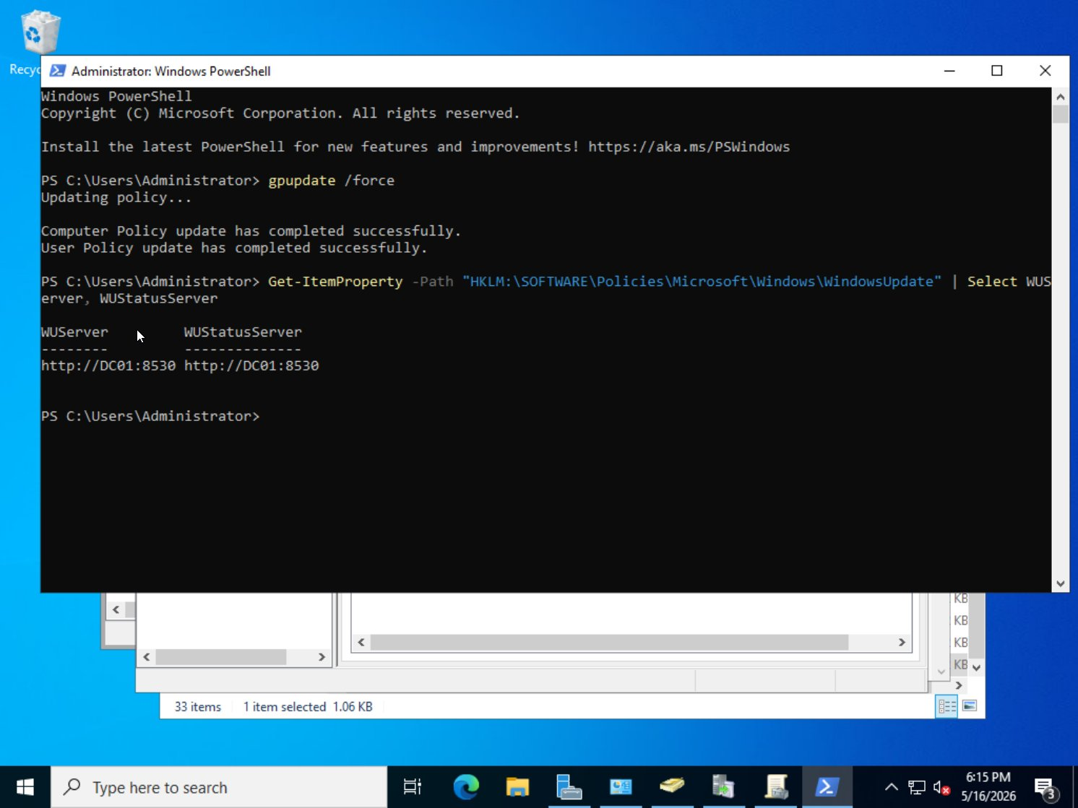
Figure 28: AFTER FIX: PowerShell registry check confirming WUServer = http://DC01:8530 and WUStatusServer = http://DC01:8530

Issue #3: Access Denied on File Share (Tool: rsop.msc)
Field | Details
Introduced | User account jfinance was removed from GRP_Finance security group in Active Directory, stripping their NTFS access to the Finance share folder on FS01
Symptom | Logging into FS01 as LAB\jfinance and navigating to C:\Shares\Finance produced an Access Denied dialog: You don't currently have permission to access this folder.
Tool Used | rsop.msc: opened on DC01 to review applied policy state and confirm security settings. Also used to demonstrate policy diagnostic tooling during the build.
Resolution | jfinance was re-added to GRP_Finance via ADUC on DC01 (Add-ADGroupMember). After signing out and back in, jfinance successfully accessed the Finance folder confirming group membership restored NTFS access.

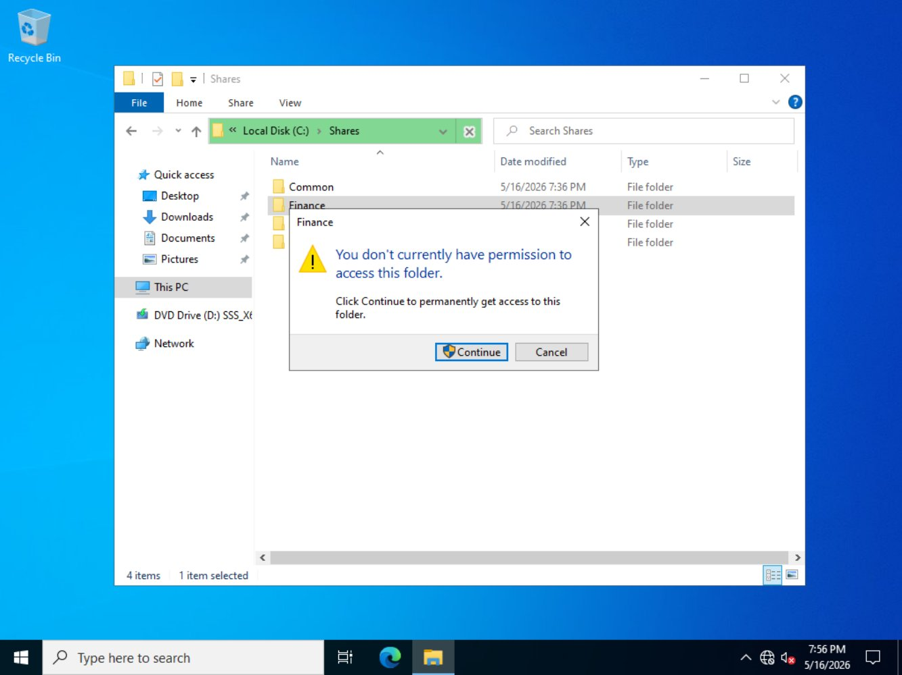
Figure 29: BEFORE FIX: jfinance receives Access Denied on Finance folder after being removed from GRP_Finance

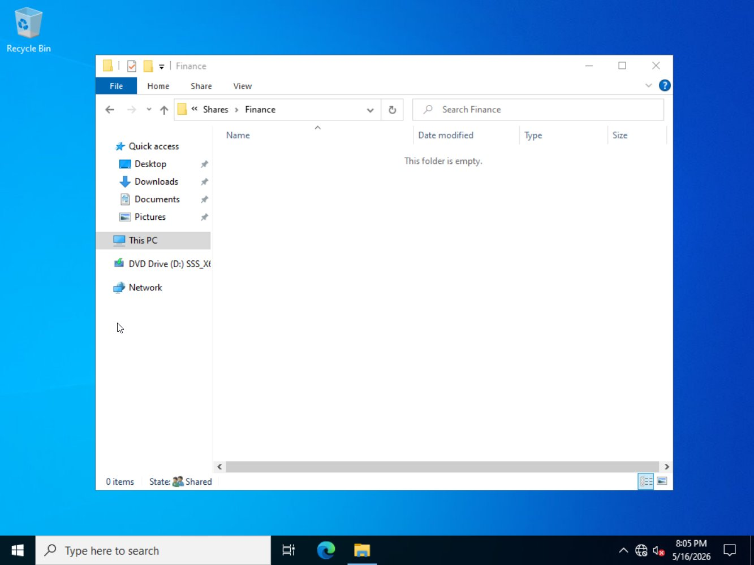
Figure 30: AFTER FIX: jfinance successfully accesses Finance folder (shown as Shared) after being restored to GRP_Finance

7. PowerShell Scripts
Three PowerShell scripts were written and used during the lab build. These are saved as .ps1 files in the 03-Scripts deliverables folder.

Script 1: SetStaticIP.ps1
Sets a static IP address, subnet mask, default gateway, and DNS server on a specified network adapter. Used during initial setup of both DC01 and FS01.

New-NetIPAddress -InterfaceAlias "Ethernet0" -IPAddress 192.168.10.10 -PrefixLength 24 -DefaultGateway 192.168.10.1 Set-DnsClientServerAddress -InterfaceAlias "Ethernet0" -ServerAddresses 127.0.0.1 # For FS01: change IP to 192.168.10.20 and DNS to 192.168.10.10

Script 2: New-OUStructure.ps1
Creates the complete Organizational Unit hierarchy under lab.local in a single execution. Run on DC01 after domain promotion.

$domain = "DC=lab,DC=local" New-ADOrganizationalUnit -Name "Lab" -Path $domain New-ADOrganizationalUnit -Name "Users" -Path "OU=Lab,DC=lab,DC=local" New-ADOrganizationalUnit -Name "Computers" -Path "OU=Lab,DC=lab,DC=local" New-ADOrganizationalUnit -Name "Servers" -Path "OU=Lab,DC=lab,DC=local" New-ADOrganizationalUnit -Name "Groups" -Path "OU=Lab,DC=lab,DC=local" New-ADOrganizationalUnit -Name "IT" -Path "OU=Users,OU=Lab,DC=lab,DC=local" New-ADOrganizationalUnit -Name "Finance" -Path "OU=Users,OU=Lab,DC=lab,DC=local" New-ADOrganizationalUnit -Name "HR" -Path "OU=Users,OU=Lab,DC=lab,DC=local"

Script 3: New-LabGroups.ps1
Creates all four security groups in the Groups OU. Run on DC01 after the OU structure is in place.

New-ADGroup -Name "GRP_IT" -GroupScope Global -GroupCategory Security -Path "OU=Groups,OU=Lab,DC=lab,DC=local" New-ADGroup -Name "GRP_Finance" -GroupScope Global -GroupCategory Security -Path "OU=Groups,OU=Lab,DC=lab,DC=local" New-ADGroup -Name "GRP_HR" -GroupScope Global -GroupCategory Security -Path "OU=Groups,OU=Lab,DC=lab,DC=local" New-ADGroup -Name "GRP_Admins" -GroupScope Global -GroupCategory Security -Path "OU=Groups,OU=Lab,DC=lab,DC=local"

8. Phase 3: Presentation Outline (20–30 Minutes)
The following structure guides the walkthrough demo. Each section has a suggested time allocation and the key things to show.

Time | Section | What to Show
0–3 min | Lab Architecture | Network topology diagram. Explain DC01 and FS01 roles, VMnet1 host-only network, NAT adapter for WSUS. VMware Workstation Pro setup.
3–8 min | Active Directory Demo | Open ADUC: show OU tree (Lab > Users > IT/Finance/HR). Show security groups in Groups OU. Show test users assigned to correct OUs and groups.
8–14 min | GPO Walkthrough | Open GPMC: walk through all 7 GPOs. Show Lab-Password-Policy lockout settings, Lab-Audit-Policy logon events, Lab-Drive-Maps with item-level targeting, Lab-RDP-Hardening firewall scope. Run gpresult /r to prove application.
14–18 min | File Share Permissions | Show permission model diagram. Open Finance$ NTFS permissions: confirm only GRP_Finance and GRP_Admins present (no individual users). Show Finance$ share access succeeding as jfinance.
18–22 min | Security Hardening | Run Get-SmbServerConfiguration: show SMB1 = False, signing = True. Open Lab-Hardening GPO: show firewall all profiles blocking inbound. Open Event Viewer: show SceCli Event 1704 policy applied.
22–26 min | Troubleshooting Demo | Walk through all 3 documented issues with before/after screenshots. Show gpresult, Event Viewer WSUS errors, and share access denied. Explain tools used to diagnose each.
26–30 min | WSUS & Scripts | Show WSUS console: synchronization history, products configured. Show Lab-WSUS-Policy GPO URL. Run one of the PowerShell scripts live. Reference GPO Catalog table.

8.1: Success Criteria Checklist

✓ | Criterion | Evidence
✅ | Domain Controller promoted, lab.local active | Fig 7, 8
✅ | Realistic OU structure with Users/Computers/Servers/Groups | Fig 9
✅ | FS01 joined to domain and in Servers OU | Fig 10
✅ | All shares use group-based permissions only: no individual users | Fig 11, 12
✅ | Password Policy GPO: 14 chars, complexity, lockout at 5 | Fig 13, 25
✅ | Audit Policy GPO: logon events and object access configured | Fig 14
✅ | Drive Maps GPO with item-level targeting per security group | Fig 15, 16
✅ | RDP hardening: NLA enforced, subnet-restricted firewall rule | Fig 17
✅ | Software Restriction: default Disallowed with path exceptions | Fig 18
✅ | WSUS configured, synced, GPO redirecting clients to DC01:8530 | Fig 19, 21
✅ | SMBv1 disabled, SMB signing enabled on all servers | Fig 22
✅ | 3 issues introduced, diagnosed with real tools, and resolved | Fig 24–30
✅ | GPO Catalog table complete with NIST 800-171 references | Section 3.8
✅ | 3 PowerShell scripts written and tested | Section 7
✅ | Network topology and permission model diagrams created | Fig 1, 11

All success criteria have been met. This lab demonstrates technical accuracy, strong adherence to least-privilege and security principles, and effective troubleshooting using industry-standard diagnostic tools.

